BIG DATA ANALYTICS LAB FILE
Manav Rachna International Institute of Research and Studies School of Computer Applications

Submitted By
Student Name | Madhur Kataria
Roll No | 25/SCA/MCAN/017
Programme | Master of Computer Applications
Semester | 3rd Semester
Section-Group | III-A
Department | Computer Applications
Batch | 2025-27
Submitted To
Faculty Name | Dr. Priyanka Dadhich


SCHOOL OF COMPUTER APPLICATIONS

S.no | Index | Date Of performance
1. | Implementing the basic commands of LINUX Operating System – File/Directory creation, deletion, update operations. | 14.08.2026
2. | Download MongoDB and analyse its client and server working. | 21.08.2026
3. | Perform CRUD Operations In Mongo DB | 28.08.2026
4. | Installation of Hadoop and virtual box | 11.09.2026
5. | Interacting with the Hadoop Distributed File System (HDFS) | 18.09.2026

EXPERIMENT NO. 1: Implementing the basic commands of LINUX Operating System – File/Directory creation, deletion, update operations.

STUDENT NAME: Madhur Kataria
UID: 25/SCA/MCAN/017
DATE OF PERFORMANCE: 14/08/2026

- AIM/OVERVIEW OF THE PRACTICAL: Overview of Linux commands.

TASK TO BE DONE:
pwd (Print Working Directory)
Description: Displays the full path of the current working directory.

ls (List Directory Contents)
Description: Lists files and directories within the current or specified directory.

cd (Change Directory)
Description: Changes the current working directory to the specified path.

mkdir (Make Directory)
Description: Creates a new directory with the specified name.

ls (Listing directory contents)
Description: The ls command is used to list files and directories within the current or specified directory.

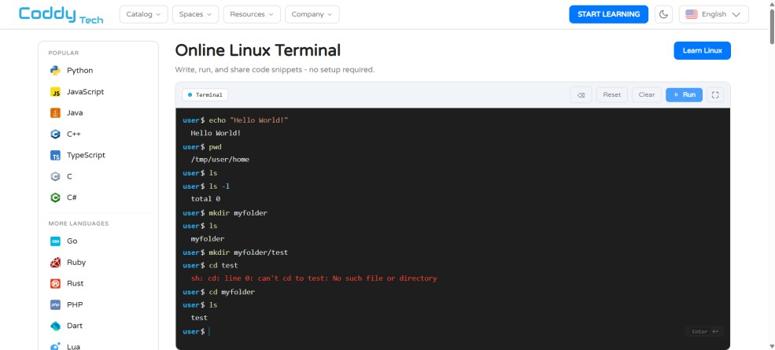
RESULT/OUTPUT/WRITING SUMMARY:

- LEARNING OUTCOME (WHAT I HAVE LEARNT): I have learnt overview of linux Commands

EXPERIMENT NO. 2: Download MongoDB and analyse its client and server working.

STUDENT NAME: Madhur Kataria
UID: 25/SCA/MCAN/017
DATE OF PERFORMANCE: 21/08/2026
- AIM/OVERVIEW OF THE PRACTICAL: Overview of MongoDB

TASK TO BE DONE:

Step:1 Go to the MongoDB download page

Step:2 Select the Community server version

Step:3 Choose your operating system and select the current release

Step:4 Click download

Step:5 Run the downloaded installer

RESULT/OUTPUT/WRITING
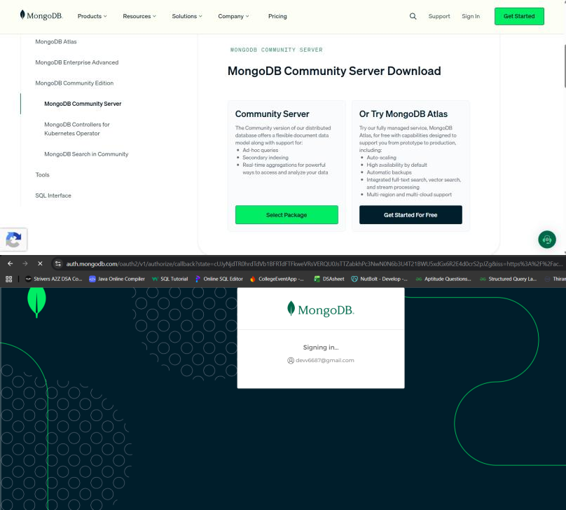

- LEARNING OUTCOME (WHAT I HAVE LEARNT): I have learnt overview of MongoDB

EXPERIMENT NO. 3: Perform CRUD Operations In Mongo DB

STUDENT NAME: Madhur Kataria
UID: 25/SCA/MCAN/017
DATE OF PERFORMANCE: 28/08/2026
- AIM/OVERVIEW OF THE PRACTICAL: CRUD Operations In Mongo DB

TASK TO BE DONE:
Step 1: Switch to a Database use collegeDB
Purpose: Switches to the database named
collegeDB.

Step 2: Create db.products.insertOne({
name: "Mobile", price: 800,
stock: 20
})
//insert multiple: db.products.insertMany([
{ name: "Tablet", price: 300, stock: 35 },
{ name: "Headphones", price: 60, stock: 40 }
])

Step 3: Read
Command 4: Display all documents
db.products.find({})
Command 5: Find one specific document db.products.findOne({ name: "Tablet" }) Command 6: Find products priced below 100 db.products.find({ price: { $lt: 100 } })

Step 4: Update db.products.updateOne(
{ name: "Mobile" },
{ $set: { price: 750 } }
)
Verify:
db.products.findOne({ name: "Mobile" })

Step 5: Delete
db.products.deleteOne({ name: "Headphones" })

RESULT/OUTPUT/WRITING :
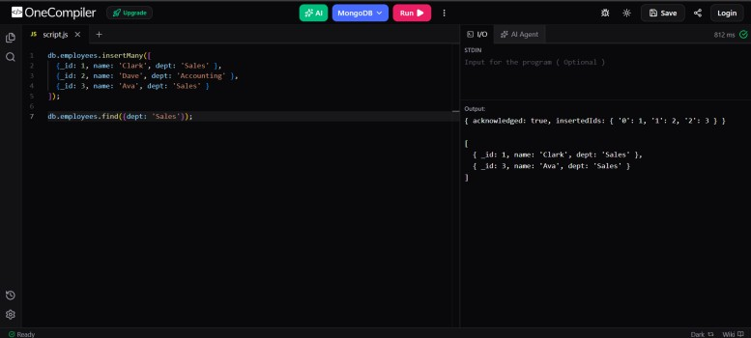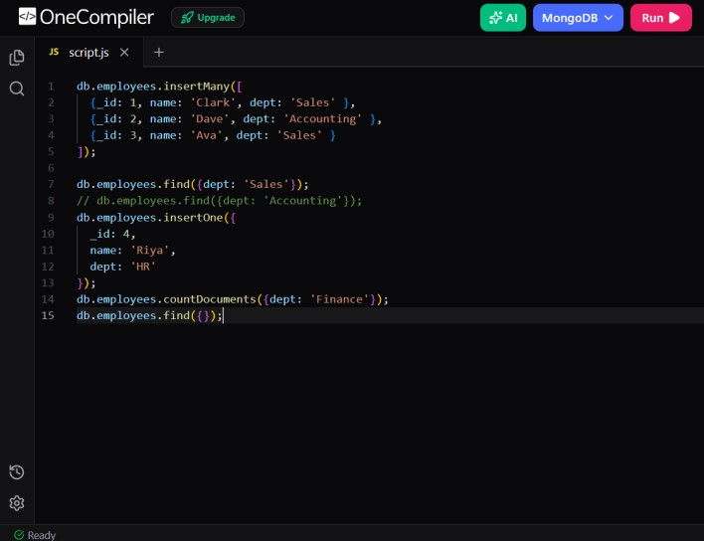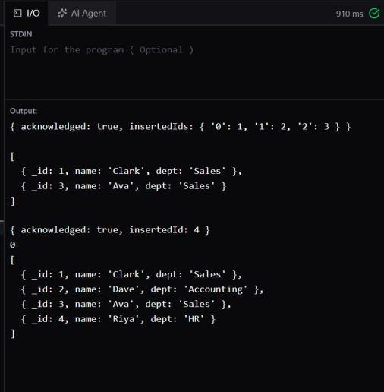
- LEARNING OUTCOME (WHAT I HAVE LEARNT): I have learnt to use the mongosh shell to perform the four fundamental CRUD (Create, Read, Update, Delete) operations.

Experiment 4 : Install virtual and Hadoop environment
STUDENT NAME: Madhur Kataria
UID: 25/SCA/MCAN/017
DATE OF PERFORMANCE: 11/09/2026

AIM/OVERVIEW OF THE PRACTICAL: Installation of VirtualBox and Hadoop Environment.

2. TASK TO BE DONE:
Step 1: Download VirtualBox
Visit the official VirtualBox website and download the installer compatible with your operating system. Install VirtualBox by following the on-screen instructions.
Step 2: Download Hadoop Environment
Download the Hadoop environment required for the practical. You can use a preconfigured Hadoop virtual machine or a compatible Hadoop installation package. Step 3: Open VirtualBox
Launch Oracle VM VirtualBox from the Start menu or Applications folder. Step 4: Import the Virtual Machine
If you are using a preconfigured Hadoop virtual machine, click File → Import Appliance.
Select the downloaded .ova file and click Next. Step 5: Configure Virtual Machine Settings
Review the virtual machine settings, including RAM, CPU, and storage. Allocate sufficient resources according to your computer's configuration and the requirements of the selected Hadoop environment.
Step 6: Import and Start the Virtual Machine
Click Import and wait for the virtual machine to be created. Once the process is complete, select the imported virtual machine and click Start.
Step 7: Log In to the Hadoop Environment
After the virtual machine starts, log in using the credentials provided with the virtual machine image.
Step 8: Verify the Hadoop Installation
Open the terminal and execute the following command to check the installed Hadoop version:
hadoop version
Step 9: Verify Hadoop Configuration
Execute the following command to check the Hadoop configuration directory: hadoop classpath
Step 10: Complete the Setup
If the commands execute successfully, the Hadoop environment is accessible. The system is now ready for performing basic Hadoop and HDFS operations.

RESULT/OUTPUT/WRITING:

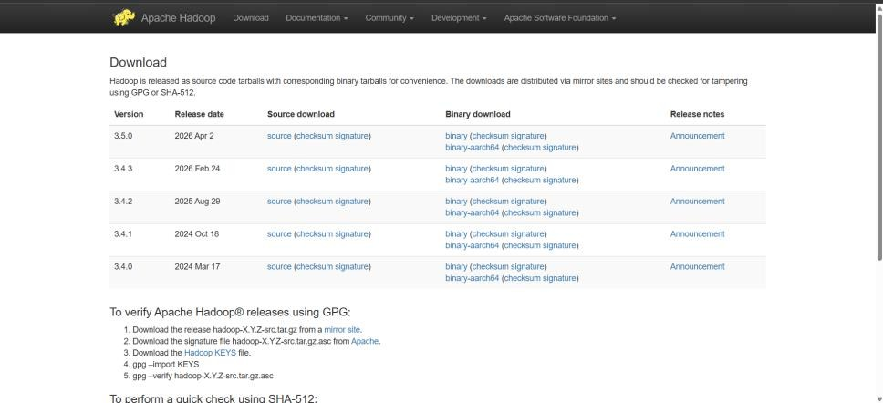

- LEARNING OUTCOME (WHAT I HAVE LEARNT): I have learnt to install Hadoop and virtual box

Experiment 5 : Interacting with the Hadoop Distributed File System (HDFS)

STUDENT NAME: Madhur Kataria
UID: 25/SCA/MCAN/017
DATE OF PERFORMANCE: 18/09/2026
- AIM/OVERVIEW OF THE PRACTICAL: To understand the basic commands for interacting with the Hadoop Distributed File System (HDFS).

TASK TO BE DONE:
Step 1: Check Hadoop Version
Open the terminal and execute the following command to check the installed Hadoop version. hadoop version
Step 2: List Files and Directories
Use the following command to display the files and directories present in the HDFS root directory. hdfs dfs -ls /
Step 3: Create a Directory in HDFS Create a directory named chirag in HDFS. hdfs dfs -mkdir /chirag
Step 4: Verify the Directory
Execute the following command to check whether the directory has been created. hdfs dfs -ls /
Step 5: Create a File in HDFS
Create an empty file named posts.txt in HDFS. hdfs dfs -touchz /chirag/posts.txt
Step 6: Display the File
List the contents of the chirag directory. hdfs dfs -ls /chirag
Step 7: Check File Size
Display the size of the file stored in HDFS. hdfs dfs -du /chirag
Step 8: Remove the File
Delete the file named posts.txt from HDFS. hdfs dfs -rm /chirag/posts.txt
Step 9: Remove the Directory
After deleting the file, remove the chirag directory. hdfs dfs -rmdir /chirag
Step 10: Verify the Final Result
Execute the following command to verify the final contents of the HDFS root directory. hdfs dfs -ls /

RESULT/OUTPUT/WRITING:
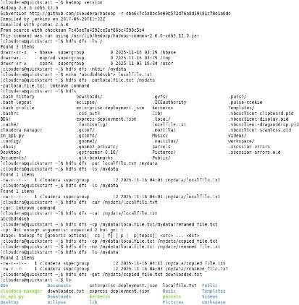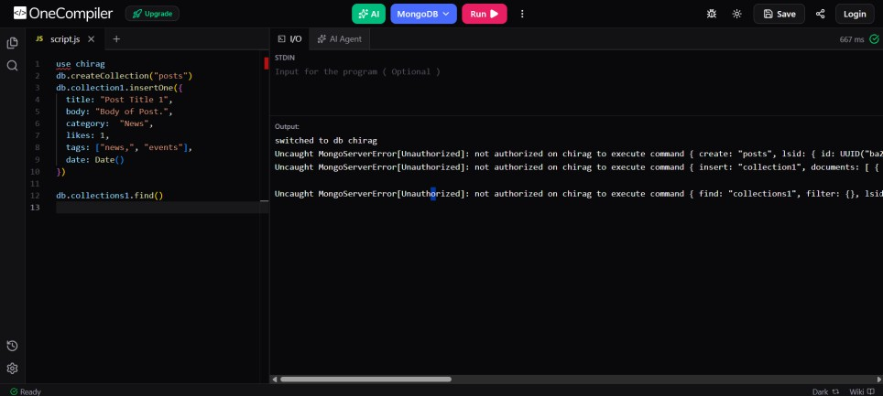
- LEARNING OUTCOME (WHAT I HAVE LEARNT): I have learnt to execute Hadoop file system commands

